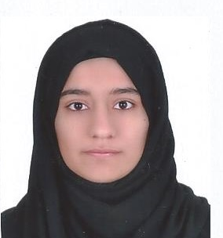
AMIRA MOHD ANWAR
Manama, Kingdom of Bahrain
Mobile:39012661
E-mail:sweet.am@live.com

Personal Details

- DATE OF BIRTH 10/6/1994
- NATIONALITY Bahraini
- MARITAL STATUS Single
- SEX Female
- RELIGION Muslim

OBJECTIVE:

Seeking an environment and prestigious guidance where I shall be able to apply and polish my skills. I am open to learning, hardworking and have taken up my courage in both my hand for strive to excel.

Educational Qualification

- HSSC II: Khawla Secondary School, BAHRAIN.
- University of Bahrain-Diploma in Office Management
- Current Student in University of Bahrain-Islamic studies.

working ExperienceS

- One-year (2015-2016): N Style International, Clerk Inventory.
- One month (2017):Ministry of Youth and Sports Affairs as a volunteer.
- One month (2018): Ministry of Youth and Sports Affairs as a volunteer.

languages known

Arabic: Read, write and speak.
English: Read, write and speak.

QUALITIES

- Hard working and can work in challenge environment.
- Have well communication skills.
- Courageous and accept challenges.

I hereby assure that the information stated above are true and correct to the best of my knowledge and belief.

AMIRA M.ANWAR

